Vertical settlement measurement
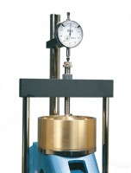 | Dial Gauge 10mm Travel X 0.002mm Divisions.  Code: 25-0440  Attributes: Description = Vertical Dial Indicator, Metric, Dial Indicator = 10 mm range x 0.002 mm<br>graduations.  Standards:

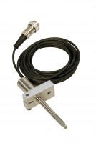 | Consolidation Transducer Assembly 15mm Travel Fitted with 5 Pin Din Plug.  Code: 27-1649  Attributes: Description = Displacement tranducer, Mounting Bracket = Included as standard.  Standards:

