Measurement of Horizontal and Vertical Movement
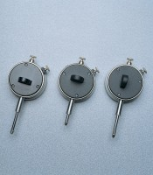 | Dial Gauge  Code: 83-5456  Attributes: Description = Dial gauge 10 mm Travel X 0.01 mm, Back Type = A  Standards:

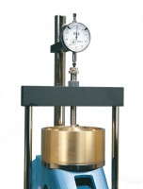 | Dial Gauge 10mm Travel X 0.002mm Divisions.  Code: 25-0440  Attributes: Description = Vertical Dial Indicator, Metric, Dial Indicator = 10 mm range x 0.002 mm<br>graduations.  Standards:

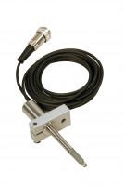 | Horizontal Displacement Transducer Assembly 15mm Travel 5 Pin Din Plug Mounting Pillar  Code: 27-1697  Attributes: Description = Horizontal displacement transducer assembly 15 mm travel, Mounting Bracket = Included as standard.  Standards:

Vertical Displacement Transducer Assembly 15mm Travel with 5 Pin Din Plug Bracket for Shear Box
Code: 27-1689
Attributes: Description = Vertical displacement transducer assembly 15 mm travel, Mounting Bracket = Included as standard.
Standards:

