Mud Augers
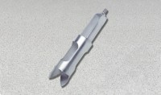 | Mud Auger  Code: 23-1382  Attributes: Diameter, ” = 3 - 1 / 4 , Description = Mud Auger  Standards:

 | Auger Extension 60"  Code: 23-1389  Attributes: Weight, lbs = 1, Description = Auger Extension 60″  Standards:

