Soil Volume Change Meter
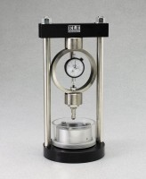 | Soil Moisture Change Meter  Code: 25-0390  Attributes: Water Required, oz = 5, Description = Soil Moisture Change Meter  Standards:

 | Porous Stone 2.74" x 0.4"  Code: 9417-0001  Attributes: Description = Porous Stone 2.74″ x 0.4″  Standards:

Porous Stone 3.0" x 5"
Code: 9417-0006
Attributes: Porous Stones dimensions diam x thick, ” = 3.0 x 0.5, Description = Porous Stone 3.0″ x 5″
Standards:

