Data Logging with the DSU
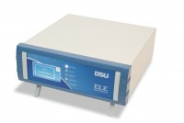 | DSU Electronic Readout and Control System 110 V AC 60 Hz  Code: 27-1300/02  Attributes: Description = DSU, Voltage Supply = 100-120 V 60 Hz  Standards:

DSU Electronic Readout and Control System 220 - 240 V AC 50/60 Hz
Code: 27-1300/01
Attributes: Voltage Supply = 220-240 V 50/60 Hz, Description = DSU
Standards:

 | Dual Frame Comms Cable  Code: 27-1300/10  Attributes: Description = Dual Frame Comms Cable, Voltage Supply = n/a  Standards:

Cable, Safety/ID
Code: 27-1300/11
Attributes: Description = Cable, Safety/ID, Voltage Supply = n/a
Standards:

PC Cable
Code: 27-1300/12
Attributes: Description = PC Cable, Voltage Supply = n/a
Standards:

