Hydraulic Constant Pressure Systems
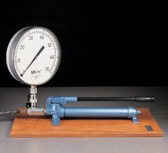 | Hand Operated Pressure System. Complete with Pressure Gauge and Flexible Hose.  Code: 70-5000  Attributes: Description = Hand Operated Pressure System, Gauge MN/m² = 300 mm diameter scale marked 0-70 MN/m2  Standards:

