Portable Dial-type Thermometers
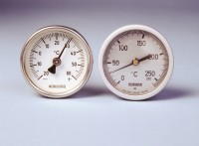 | Portable Thermometer +50 - +250°CPortable Thermometer +50 - +250°CPortable Thermometer +50 - +250°CP  Code: 82-5243  Attributes: Temperature Range °C = +50 to +250  Standards:

Portable Thermometer -30 - +60°C
Code: 82-5244
Attributes: Temperature Range °C = -30 to +60
Standards:

Portable Thermometer 0 - +250°C
Code: 82-5245
Attributes: Temperature Range °C = 0 to +250
Standards:

Portable Thermometer -20 - +60°C
Code: 82-5246
Attributes: Temperature Range °C = -20 to +60
Standards:

Portable Thermometer 100 ml
Code: 82-5247
Attributes: Temperature Range °C = 0 to +100
Standards:

Portable Thermometer 0 - +250°C
Code: 82-5248
Attributes: Temperature Range °C = 0 to +250
Standards:

