Press-Ur-Meter
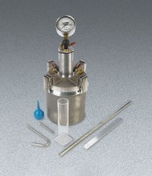 | Press-Ur-Meter Type A  Code: 34-3267  Attributes: Pump = Built-in, Description = Press-Ur-Meter Type A  Standards: ASTM C231, AASHTO T152

 | Calibration Container  Code: 34-3267/10  Attributes: Weight, lbs = 2, Description = Calibration Container  Standards: ASTM C231, AASHTO T152

