Accu-Tek Touch 350 Series
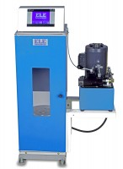 | Accu-Tek Touch 350 Series 220V/50Hz  Code: 36-0735/01  Attributes: Range, lbf = 3,500 - 350,000, Description = Accu-Tek Touch 350 Series 220V/50Hz  Standards: ASTM C39, AASHTO T22

Accu-Tek Touch 350 Series 110V/60Hz
Code: 36-0735/02
Attributes: Range, lbf = 3,500 - 350,000, Description = Accu-Tek Touch 350 Series 110V/60Hz
Standards: ASTM C39, AASHTO T22

Accu-Tek Touch 350 Series 220V/60Hz
Code: 36-0735/06
Attributes: Range, lbf = 3,500 - 350,000, Description = Accu-Tek Touch 350 Series 220V/60Hz
Standards: ASTM C39, AASHTO T22

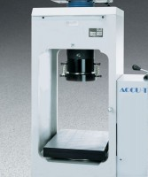 | Platen Set for 6" x 12" Concrete Cylinders  Code: 37-5500  Attributes: Dimensions, diameter x length, ” = 6.5 x 6.75, Description = Platen Set for 6″ x 12″ Concrete Cylinders  Standards: ASTM C39, AASHTO T22

 | Platen Set 3" x 6" Concrete Cylinders  Code: 37-5504  Attributes: Dimensions, diameter x length, ” = 4 x 14.75, Description = Platen Set 3″ x 6″ Concrete Cylinders  Standards: ASTM C39, AASHTO T22

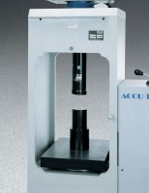 | Platen Set for 2" Cubes  Code: 37-5510  Attributes: Dimensions, diameter x length, ” = 4 x 16.75, Description = Platen Set for 2″ Cubes  Standards: ASTM C109, ASTM C39, AASHTO T22

Platen Set for Blocks up to 10"
Code: 37-5520
Attributes: Description = Platen Set for Blocks up to 10″, Dimensions, l x w x h, ” = 14 x 10 x 8.25
Standards:

Pedestal for Testing 4" x 8" Cylinders
Code: 37-5561
Attributes: Dimensions, diameter x length, ” = 6 x 4, Description = Pedestal for Testing 4″ x 8″ Cylinders
Standards: ASTM C39, AASHTO T22

Ram Seal
Code: 4699-1315
Attributes: Diameter, ” = 197 mm, Description = Ram Seal
Standards:

Accutek Oil
Code: 9806-0016
Attributes: Dimensions, l x w x h, ” = 6 x 6 x 12, Description = Accutek Oil
Standards: ASTM Grade 215, ISO Grade 46

Flexural Attachment
Code: 37-5524
Attributes: Description = Flexural Attachment - 95 kg, Upper Head = Uses toe hitch design to mount to upper crosshead.
Standards: ASTM C78, ASTM C293, AASHTO T97

Frame Stand
Code: 37-5575
Attributes: Description = Frame Stand - 29 x 20 x 20 ", For use with = Accu-Tek 350 and 500, Dimensions, l x w x h, ” = 29 x 20 x 20
Standards:

