Rapid-Change Cylinder Platen Sets
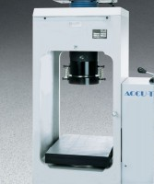 | Platen Set for 6" x 12" Concrete Cylinders  Code: 37-5500  Attributes: Dimensions, diameter x length, ” = 6.5 x 6.75, Description = Platen Set for 6″ x 12″ Concrete Cylinders  Standards: ASTM C39, AASHTO T22

 | Platen Set 3" x 6" Concrete Cylinders  Code: 37-5504  Attributes: Dimensions, diameter x length, ” = 4 x 14.75, Description = Platen Set 3″ x 6″ Concrete Cylinders  Standards: ASTM C39, AASHTO T22

Pedestal for Testing 4" x 8" Cylinders
Code: 37-5561
Attributes: Dimensions, diameter x length, ” = 6 x 4, Description = Pedestal for Testing 4″ x 8″ Cylinders
Standards: ASTM C39, AASHTO T22

