Load Measurement
 | Distance Piece Stainless Steel for Use with Submerisble Load Cells and Axial Strain Transducers.  Code: 27-1293  Attributes: Description = Distance piece stainless steel for use with submersible load cells, Load device type = Stainless Steel distance piece for use with submersible loads cells, Weight, lbs = 1  Standards:

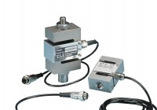 | S-Type Load Cell 5 kN.for Triaxial Tests. Fitted with 5 Pin Din Plug.  Code: 27-1551  Attributes: Load device type = S-Type, Force Capacity, kN = 5, Description = S-Type load cell, Environmental Protection = IP65  Standards:

S-Type Load Cell 10 kN.for Triaxial Tests. Fitted with 5 Pin Din Plug.
Code: 27-1553
Attributes: Load device type = S-Type, Force Capacity, kN = 10, Description = S-Type load cell, Environmental Protection = IP65
Standards:

S-Type Load Cell 25 kN.for Triaxial Tests. 27-1293 required separately.
Code: 27-1555
Attributes: Load device type = S-Type, Force Capacity, kN = 25, Description = S-Type load cell, Environmental Protection = IP65
Standards:

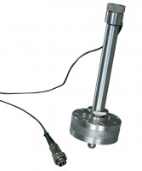 | Submersible Load Transducer Assembly 5kN Capacity In Compression.  Code: 27-1573  Attributes: Load device type = Submersible, Force Capacity, kN = 5, Description = Submersible load transducer, Weight, lbs = 2.25  Standards:

Submersible Load Transducer Assembly 10kN Capacity In Compression.
Code: 27-1575
Attributes: Load device type = Submersible, Force Capacity, kN = 10, Description = Submersible load transducer, Compensated Temperature Range = 0 - 50
Standards:

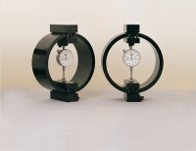 | Clamped Boss Load Ring - 4.5 kN  Code: 78-0260  Attributes: Description = Load ring - 4.5 kN, Load device type = Load ring, Force Capacity, kN = 4.5, Weight, lbs = 9.25  Standards:

Clamped Boss Load Ring - 28.0 kN
Code: 78-0760
Attributes: Description = Load ring - 28 kN, Load device type = Load ring, Force Capacity, kN = 28, Value of CBR % = Average range of CBR, Overall Height, mm = 248
Standards:

50kN Load Measuring Ring
Code: 78-0860
Attributes: Description = Load ring - 50 kN, Value of CBR % = Above 40%, Overall Height, mm = 248, Force Capacity, kN = 50, Load device type = Load ring
Standards: EN 12697-34

