Vacuum Pumps
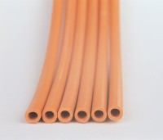 | Rubber Tubing  Code: 81-0375  Attributes: Description = Rubber Tubing  Standards:

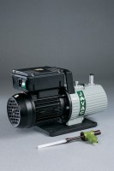 | Filter Pump  Code: 82-7700  Attributes: Description = Filter Pump, Working Pressure, kPa = 14  Standards:

Vacuum Pump
Code: 82-7720/01
Attributes: Description = Vacuum Pump, Power Supply = 220 - 240 V AC, 50 - 60 Hz, 1 ph
Standards:

 | Vacuum Oil  Code: 82-7720/10  Attributes: Description = Vacuum Oil  Standards:

Water Trap
Code: 82-7720/12
Attributes: Description = Water Trap
Standards:

