Inspection Vane
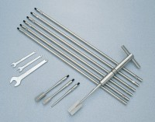 | H60 Field Inspection Vane Tester 0-200Kpa In Carrying Case. includes calibration and certificates.  Code: 26-3335  Attributes: Description = H60 Field Inspection Vane Tester  Standards:

 | H605 Extension Rod 0.5M and connection piece  Code: 26-3335/11  Attributes: Description = H605 extension rod  Standards:

