ADR TOUCH Digital Readout Unit Accessories
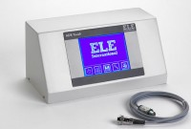 | ADR TOUCH Digital Readout Unit  Code: 37-4856/09  Attributes: Transducer Excitation = 0.05…10V, Description = ADR TOUCH Digital Readout Unit  Standards: ASTM C39, ASTM C78, ASTM C104, ASTM C109, ASTM C293, AASHTO T22, AASHTO T97

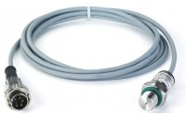 | Pressure Transducer  Code: 37-4856/10  Attributes: Description = Pressure Transducer  Standards:

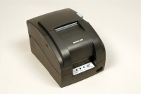 | Impact Printer Rs232 Serial Connection. Supplied Complete with 1 Paper Roll.  Code: 37-4859/02  Attributes: Description = Impact Printer RS232 Serial Connection  Standards:

 | Printer Ribbon(Black/Red) for Use with Impact Printer.  Code: 37-4859/10  Attributes: Description = Printer Ribbon  Standards:

Paper Roll 76mm Wide (Box of 20)
Code: 37-4859/12
Attributes: Description = Paper Roll
Standards:

