Semi-Automatic Cone Penetrometer
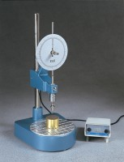 | Semi-Automatic Cone Penetrometer to BS:1377:Part 2  Code: 24-0545/01  Attributes: Description = Semi-Automatic Cone Penetrometer, Weight, kg = 8.6, Voltage Supply = 220-240 V 50/60 Hz, Cone Relase = Semi-Automatic  Standards:

