Sand Equivalent Test Set
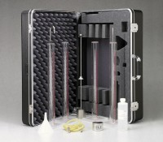 | Sand Equivalent Test Set  Code: 24-4917  Attributes: Stock Solution = Mixture of calcium chloride and glycerin., Description = Sand Equivalent Test Set  Standards: ASTM D2419, AASHTO T176

 | Sand Equivalent Cylinder  Code: 24-4917/10  Attributes: Dimensions, diameter x length, ” = 1-1/4 x 17, Description = Sand Equivalent Cylinder  Standards: ASTM D2419, AASHTO T176

Stock Solution 8 oz.
Code: 24-4936
Attributes: Stock Solution = Mixture of calcium chloride and glycerin., Description = Stock Solution 8 oz.
Standards: ASTM D2419, AASHTO T176

Stock Solution 1 gallon
Code: 24-4938
Attributes: Stock Solution = Mixture of calcium chloride and glycerin., Description = Stock Solution 1 gallon
Standards: ASTM D2419, AASHTO T176

