Mortar Mixer, 5 Qt.
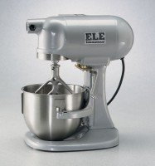 | Mortar Mixer, 230V  Code: 39-0075/01  Attributes: Beater = Flat-type; stainless steel., Description = Mortar Mixer, 230V  Standards:

Mortar Mixer, 115V
Code: 39-0075/02
Attributes: Beater = Flat-type; stainless steel., Description = Mortar Mixer, 115V
Standards: ASTM C305, AASHTO T162

 | Stainless Steel Bowl  Code: 39-0075/10  Attributes: Description = Stainless Steel Bowl  Standards:

Stainless Steel Beater
Code: 39-0075/12
Attributes: Description = Stainless Steel Beater
Standards:

