Hand-Operated Liquid Limit Devices
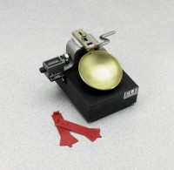 | Liquid Limit Device  Code: 24-0435  Attributes: Grooving Tools = ASTM type; plastic; pkg. of 10 (included)., Description = Liquid Limit Device  Standards: ASTM D4318, AASHTO T89

 | Brass Cup  Code: 24-0435/10  Attributes: Dimensions w x d x h, ” = 88x88x2 mm, Description = Brass Cup  Standards: ASTM D4318, AASHTO T89

ASTM Slider and Pin Cup Holder Assembly
Code: 24-0435/12
Attributes: Dimensions w x d x h, ” = 84x40x10 mm, Description = ASTM Slider and Pin Cup Holder Assembly
Standards: ASTM D4318, AASHTO T89

Liquid Limit Device with counter
Code: 24-0437
Attributes: Grooving Tools = ASTM type; plastic; pkg. of 10 (included)., Description = Liquid Limit Device with counter
Standards: ASTM D4318, AASHTO T89

ASTM Plastic Grooving Tools
Code: 24-0451
Attributes: Gauge height, cm = 1, Description = ASTM Plastic Grooving Tools
Standards: ASTM D4318

