Determination of Plastic Limit
 | Glass Plate.  Code: 24-0430  Attributes: Description = Glass plate, BS/EN Standard = Yes  Standards: BS 1377, EN 1997-2

Rod Comparator
Code: 24-0811
Attributes: Description = Rod comparator, Diameter, ” = 3
Standards: BS 1924-2, EN 1997-2, ASTM D4318, BS 1377, AASHTO T90

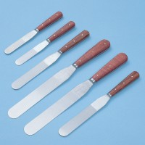 | Spatula 200 mm  Code: 81-0140  Attributes: Description = Spatula 200 mm  Standards:

