Digital Hotplate
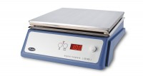 | Digital Hotplate  Code: 78-3104/01  Attributes: Voltage Supply = 220 - 240 V AC, 50 Hz  Standards:

