Cube Moulds
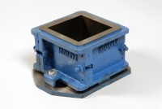 | 100mm Cube Mould 4-Part Clamp Type. Cast Iron Construction. BS EN Compliant.  Code: 34-4520  Attributes: Cube mould type = 4 part, Specimen Size = 100 x 100 mm, Internal Dimensions dia x h, ” = 100 x 100 x 100  Standards:

150mm Cube Mould 4-Part Clamp Type. Cast Iron Construction. BS EN Compliant.
Code: 34-4570
Attributes: Specimen Size = 150 x 150 mm, Cube mould type = 4 part, Internal Dimensions dia x h, ” = 150 x 150 x 150
Standards:

