ELE Sieve Shaker
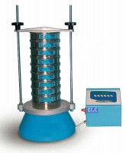 | ELE Sieve Shaker  Code: 80-0200/01  Attributes: Voltage Supply = 220 - 240 V AC, 50 Hz  Standards:

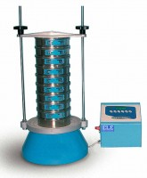 | ELE Sieve Shaker  Code: 80-0200/06  Attributes: Voltage Supply = 220 - 240 V AC, 60 Hz  Standards:

