Flow Table
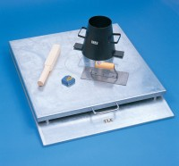 | Apparatus for Determining Flow In Concrete (Flow Table).  Code: 34-0450  Attributes: Description = Flow Table  Standards:

