Unit Weight Measures
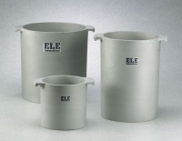 | Unit Weight Measure 1/10 cu. Ft. Capacity  Code: 34-2850  Attributes: Capacity, g = 1/10, Description = Unit Weight Measure 1/10 cu. Ft. Capacity  Standards: ASTM C29

Unit Weight Measure 1/3 cu. Ft. Capacity
Code: 34-2852
Attributes: Capacity, g = 1/3, Description = Unit Weight Measure 1/3 cu. Ft. Capacity
Standards: ASTM C29

Unit Weight Measure 1/2 cu. Ft. Capacity
Code: 34-2854
Attributes: Capacity, g = 1/2, Description = Unit Weight Measure 1/2 cu. Ft. Capacity
Standards: ASTM C29

Unit Weight Measure 1 cu. Ft. Capacity
Code: 34-2856
Attributes: Capacity, g = 1, Description = Unit Weight Measure 1 cu. Ft. Capacity
Standards: ASTM C29

