Los Angeles Abrasion Machine
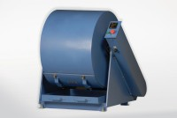 | Los Angeles Abrasion Machine Meets ASTM and European Standards. 220-240V 50Hz 1Ph.  Code: 42-5305/01  Attributes: Description = Los Angeles Abrasion Machine 220- 240 V AC 50Hz, Motor hp, amp = 1 HP  Standards: EN 1097-2, ASTM C131, ASTM C535, AASHTO T96, NF P18-573

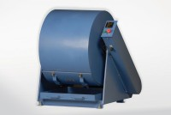 | Los Angeles Abrasion Machine  Code: 42-5305/02  Attributes: Description = Los Angeles Abrasion Machine 110-120 V AC 60 Hz, Motor hp, amp = 1 HP  Standards: ASTM C131, ASTM C535, AASHTO T96, NF P18-573

Los Angeles Abrasion Machine
Code: 42-5305/06
Attributes: Description = Los Angeles Abrasion Machine 220-240 V AC 60 Hz, Motor hp, amp = 1 HP
Standards: ASTM C131, ASTM C535, AASHTO T96

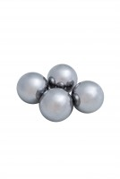 | Set of 12 Abrasive Charges (ASTM).  Code: 42-5300/10  Attributes: Description = 12 ASTM Abrasive Charges, Weight, lbs = 11.3  Standards: EN 1097-2, ASTM C131, ASTM C535, AASHTO T96

