Strain Gauge
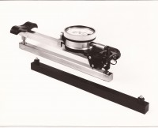 | 200mm "Demec" Mechanical Strain Gauge  Code: 35-2846  Attributes: Description = Demec Mechanical Strain Gauge - 200 mm  Standards: BS 1881-206

