Aluminium Moisture Boxes
 | Aluminium Moisture Cans - 2" Diameter  Code: 88-7002  Attributes: Lid = Fits onto bottom as well as top of box., Description = Aluminium Moisture Boxes - 2″ Diameter  Standards:

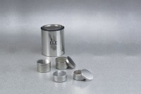 | Aluminium Moisture Cans - 2-1/2" Diameter  Code: 88-7004  Attributes: Lid = Fits onto bottom as well as top of box., Description = Aluminium Moisture Boxes - 2-1/2″ Diameter  Standards:

Aluminium Moisture Cans - 3-1/2" Diameter
Code: 88-7008
Attributes: Lid = Fits onto bottom as well as top of box., Description = Aluminium Moisture Boxes - 3-1/2″ Diameter
Standards:

