Axial Displacement
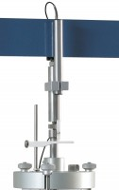 | Axial Strain Transducer Assembly 50mm Travel Fitted with 5 Pin Din Plug.  Code: 27-1617  Attributes: Description = Axial strain transducer assembly 50mm travel, Mounting Bracket = Included as standard.  Standards:

