Volumeasure
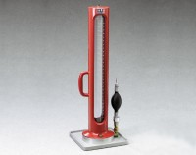 | Volumeasure  Code: 29-4522  Attributes: Weight, lbs = 14, Description = Volumeasure  Standards: ASTM D2167, AASHTO T205

 | Balloons  Code: 29-4522/10  Attributes: Construction = rubber, Description = Balloons  Standards: ASTM D2167, AASHTO T205

Graduated Cylinder and Gasket Set
Code: 29-4522/11
Attributes: Weight, lbs = 1.31, Description = Graduated Cylinder and Gasket Set
Standards: ASTM D2167, AASHTO T205

Actuator Bulb Assembly
Code: 29-4522/13
Attributes: Weight, lbs = 0.184, Description = Actuator Bulb Assembly
Standards: ASTM D2167, AASHTO T205

Volumeasure Pressure Gauge
Code: 29-4524
Attributes: Pressure Gauge, psi = 15, Description = Volumeasure Pressure Gauge
Standards: ASTM D2167, AASHTO T205

