Penetration Measurement
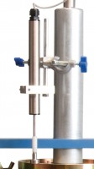 | CBR Penetration Transducer 50mm Travel Fitted with 5 Pin Din Plug.  Code: 27-1705  Attributes: Description = Penetration transducer, Mounting Bracket = Included  Standards:

