Accessories for the Marshall test
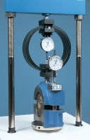 | Breaking Head (Marshall)  Code: 45-6850  Attributes: Description = Breaking Head, Weight, kg = 9  Standards: EN 12697-34

 | Flow Meter BS/EN  Code: 45-6880  Attributes: Description = Flow Meter BS/EN, Weight, kg = 0.61  Standards: EN 12697-34

Flow Meter
Code: 45-6890
Attributes: Description = Flow Meter, Weight, kg = 0.61
Standards: EN 12697-34

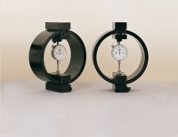 | 50kN Load Measuring Ring  Code: 78-0860  Attributes: Description = Load ring - 50 kN, Value of CBR % = Above 40%, Overall Height, mm = 248, Force Capacity, kN = 50, Load device type = Load ring  Standards: EN 12697-34

