Electric Pump Attachment
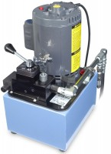 | Electric Pump Attachment 110vAC  Code: 37-5574/02  Attributes: Normal Operating Pressure = Swivel seat type; 6-1/4” (15 9 mm) diameter., Description = Electric Pump Attachment 110vAC  Standards:

Electric Pump Attachment 220vAC
Code: 37-5574/06
Attributes: Normal Operating Pressure = Swivel seat type; 6-1/4” (15 9 mm) diameter., Description = Electric Pump Attachment 220vAC
Standards:

 | Accutek Oil  Code: 9806-0016  Attributes: Dimensions, l x w x h, ” = 6 x 6 x 12, Description = Accutek Oil  Standards: ASTM Grade 215, ISO Grade 46

