ES Series Low Profile Bench Scales
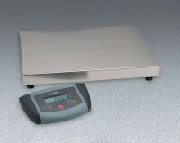 | ES Series Low Profile Bench Scale 110 lb Capacity  Code: 88-1424/02  Attributes: Rated Power = 9 vDC AC adaptor (included) or six “AA” batteries (not included)., Description = ES Series Low Profile Bench Scale 110 lb Capacity  Standards:

ES Series Low Profile Bench Scale 220 lb Capacity
Code: 88-1428/02
Attributes: Rated Power = 9 vDC AC adaptor (included) or six “AA” batteries (not included)., Description = ES Series Low Profile Bench Scale 220 lb Capacity
Standards:

