Calibrated Crack Monitor
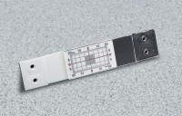 | Calibrated Crack Monitor  Code: 35-2510  Attributes: Coefficient of Thermal Expansion, °F = 3.80 x 10-5 in/in/°F. (6.84 x 10-5 mm/mm/°C)., Description = Calibrated Crack Monitor  Standards:

