Accessories for manual and automatic compaction
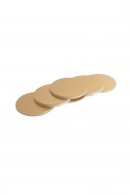 | Paper Discs  Code: 45-6462  Attributes: Description = Paper Discs, Weight, oz. = 2.9  Standards: EN 12697-30

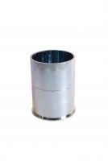 | Compaction Mould  Code: 45-6310  Attributes: Description = Compaction Mould, Dimensions, i.d x int. ht. = 4" (101.6 mm) i.d. x 3" (76.2 mm) internal h. with base  Standards: EN 12697-30, ASTM D6926, AASHTO T245

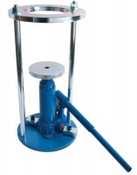 | Proctor/Core Cutter Extruder Frame and Hydraulic Jack. Extrudes 100mm/4 Inch Diameter Specimens  Code: 23-4200  Attributes: Description = Proctor /Core Cutter Extruder, Extrudes samples from = BS compaction mould<br>Proctor Mould<br>100 mm core cutter<br>Marshall mould  Standards: BS 1377-1

 | Compaction Mould Body  Code: 45-6310/10  Attributes: Description = Compaction Mould Body  Standards: EN 12697-30

Baseplate
Code: 45-6310/11
Attributes: Description = Baseplate
Standards: EN 12697-30

Filling/Extraction Collar
Code: 45-6310/12
Attributes: Description = Filling/Extraction Collar
Standards: EN 12697-30

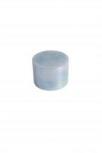 | Steel Block  Code: 45-6463  Attributes: Description = Steel Block  Standards: EN 12697-30

30 L Heating Bath with Led Display Cover
Code: 45-6550/01
Attributes: Description = 30 L Heating Bath
Standards: BS 2000-49, EN 1426, EN 13179-2, ASTM D5, AASHTO T49, IP 49

