Core Barrels
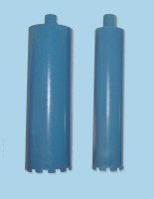 | Core Barrel 100 mm  Code: 47-5565  Attributes: Length, mm = 100  Standards: EN 12697-32, EN 13280-4, BS 598-104

Core Barrel 150 mm
Code: 47-5605
Attributes: Length, mm = 150
Standards: EN 12697-32, EN 13280-4, BS 598-104

