Plastic Flat Bottom Scoops
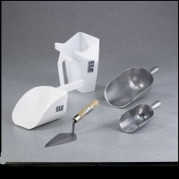 | Plastic Flat Bottom Scoop - 1 qt. Capacity  Code: 88-7310  Attributes: Dimensions w x d x h, ” = 6-3/4 x 5-1/4 x 3-1/4, Description = Plastic Flat Bottom Scoop - 1 qt. Capacity  Standards:

Plastic Flat Bottom Scoop - 2 qt. Capacity
Code: 88-7312
Attributes: Dimensions w x d x h, ” = 8-1/4 x 6 x 5, Description = Plastic Flat Bottom Scoop - 2 qt. Capacity
Standards:

