Rapid Moisture Testers
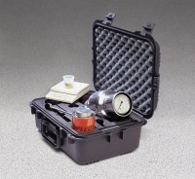 | Speedy Moisture Tester D2 Large 0-20% Moisture Range. Supplied Less Calcium Carbide  Code: 23-7452  Attributes: Model/type = D2 Large, Moisture range % = 0 to 20, Gauge divisions % = 0.2, Sample weight g = 20, Dimensions w x d x h, ” = 518x382x212 mm, Description = Speedy Moisture Tester  Standards: BS 812, ASTM D4944, AASHTO T217

 | Speedy Calibration Unit Self Contained Unit.  Code: 23-7600  Attributes: Description = Speedy Calibration Unit, Weight, lbs = 13  Standards: ASTM D4944, AASHTO T217

Reagent for Speedy Moisture Testers. Pack of 12 Cans 500 G Each. (Calcium Carbide)
Code: 23-7702
Attributes: Description = Calcium carbide powder - 12 x 500 g, Stock Solution = Calcium Carbide
Standards: ASTM D4944, AASHTO T217

Portable Electronic Balance
Code: 23-7452/12
Attributes: Scale = 0-200 g, Description = Portable Electronic Balance
Standards: ASTM D4944, AASHTO T217

