Compact Core Drill Machine
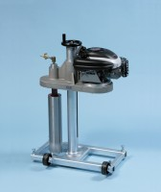 | Compact Core Drill  Code: 47-5175  Attributes: Description = Compact Core Drill  Standards: EN 12697-32, EN 13280-4, BS 598-104

