Asphalt Centrifuge Extractors
 | Filter Discs Pack of 100  Code: 45-3803  Attributes: Description = Filter Discs Pack of 100, Capacity, Grams = 1,500, Filter Discs = 100  Standards: EN 12697-1, ASTM D2172, AASHTO T164

Filter Discs Pack of 100
Code: 45-3807
Attributes: Description = Filter Discs Pack of 100, Capacity, Grams = 3,000, Filter Discs = 100
Standards: EN 12697-1, ASTM D2172, AASHTO T164

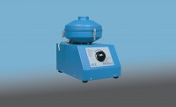 | Rotatest 1500  Code: 45-3810/01  Attributes: Description = Rotatest, Capacity, Grams = 1,500  Standards: EN 12697-1, ASTM D2172, AASHTO T164

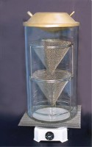 | Replacement bowl for Rotatest 1500 centrifuge extractor  Code: 45-3810/10  Attributes: Description = Replacement bowl for Rotatest, Capacity, Grams = 1,500  Standards: EN 12697-1, ASTM D2172, AASHTO T164

Rotatest 3000
Code: 45-3815/01
Attributes: Description = Rotatest, Capacity, Grams = 3,000
Standards: EN 12697-1, ASTM D2172, AASHTO T164

Replacement bowl for Rotatest 3000 centrifuge extractor
Code: 45-3815/10
Attributes: Description = Replacement bowl for Rotatest, Capacity, Grams = 3,000
Standards:

