Spatulas
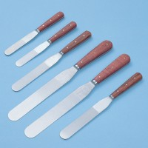 | Spatula 100 mm  Code: 81-0100  Attributes: Description = Spatula 100 mm  Standards:

Spatula 150 mm
Code: 81-0120
Attributes: Description = Spatula 150 mm
Standards:

Spatula 200 mm
Code: 81-0140
Attributes: Description = Spatula 200 mm
Standards:

 | Chattaway Spatula 125 mm  Code: 81-0180  Attributes: Description = Chattaway Spatula 125 mm  Standards:

