Paqualab Standard Systems
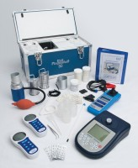 | Paqualab System 50 for Analysis of Drinking Water to Ec Standard Categories 1 & 2.  Code: 418-160  Attributes: Description = Paqualab System 50  Standards:

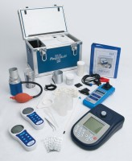 | Paqualab System 25 for Analysis of Drinking Water to Ec Standard Categories 1 & 2.  Code: 418-150  Attributes: Description = Paqualab System 25  Standards:

 | Paqualab lightweight System 25L for analysis of drinking water to EC Staandard Categories 1 & 2  Code: 418-100  Attributes: Description = Paqualab Lightweight System 25L  Standards:

