Digital Pocket Thermometers
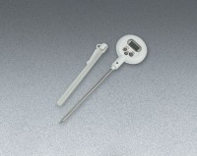 | Digital Pocket Thermometer  Code: 88-4434  Attributes: Accuracy, % = 0.1F or 0.1C, Description = Digital Pocket Thermometer  Standards: ASTM D854

