Measurement of Load (Shear Stress)
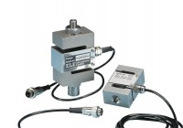 | S-Type Load Cell 5 kN.for Use with Direct/ Residual Shear Machine. Fitted with 5 Pin Din Plug.  Code: 27-1561  Attributes: Description = S-Type load cell, Force Capacity, kN = 5, Environmental Protection = IP65  Standards: BS 1377, ASTM D3080

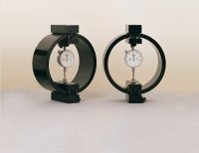 | Clamped Boss Load Ring - 2.0 kN  Code: 78-0060  Attributes: Description = Load ring - 2 kN, Force Capacity, kN = 2, Value of CBR % = Up to 8%, Capacity, lbf = 450, Capacity kN = 2.0  Standards: BS 1377, ASTM D3080

Clamped Boss Load Ring - 3.0 kN
Code: 78-0160
Attributes: Description = Load ring - 3 kN, Force Capacity, kN = 3, Weight, lbs = 9.25
Standards: BS 1377, ASTM D3080

