Triple Beam Scales
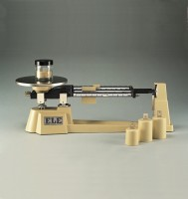 | Triple Beam Balance  Code: 78-7140  Attributes: Description = Triple Beam Balance, Weight, lbs = 8  Standards:

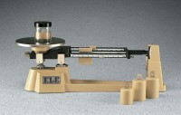 | Triple Beam Scale - 2,610 g Capacity; with Undivided Tare Beam, Tares up to 225 g  Code: 78-7142  Attributes: Attachment Weights = One 500 g; two 1,000 g (included)., Description = Triple Beam Scale - 2,610 g Capacity; with Undivided Tare Beam, Tares up to 225 g  Standards:

