Cutting Edge
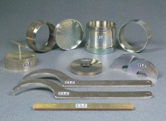 | ASTM Cutting Collar.  Code: 24-9236  Attributes: Description = CBR cutting collar, Mould Dimensions, i.d x h, ” = 6 x 1-1/2  Standards: ASTM D1883, AASHTO T193

