Dual-Scale, Maximum-Minimum Thermometer
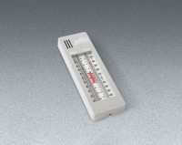 | Dual-Scale, Maximum-Minimum Thermometer  Code: 88-4612  Attributes: Accuracy, % = 1, Description = Dual-Scale, Maximum-Minimum Thermometer  Standards:

