Dual Frame Compression Machines
 | ADR-Auto V2.0 BS EN 2000/250kN Compression Machine  Code: 36-4155/01  Attributes: Frame 1 = 2000 kN, Frame 2 = 250 kN, Voltage Supply = 220-240 V 50 Hz  Standards: EN 12350-6, EN 196-1

ADR-Auto V2.0 BS EN 2000/250kN Compression Machine
Code: 36-4155/06
Attributes: Frame 1 = 2000 kN, Frame 2 = 250 kN, Voltage Supply = 220-240 V 60 Hz
Standards: EN 12350-6, EN 196-1

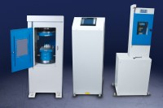 | ADR-Auto V2.0 BS EN 3000/250kN Compression Machine  Code: 36-4170/01  Attributes: Frame 1 = 3000 kN, Frame 2 = 250 kN, Voltage Supply = 220-240 V 50 Hz  Standards: EN 12350-6, EN 196-1

