Displacement Transducers
 | CBR Displacement Transducer  Code: 27-1706  Attributes: Mounting Bracket = Included as standard., Description = CBR Displacement Transducer  Standards:

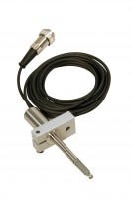 | Consolidation Transducer Assembly 15mm Travel Fitted with 5 Pin Din Plug.  Code: 27-1649  Attributes: Description = Displacement tranducer, Mounting Bracket = Included as standard.  Standards:

Horizontal Displacement Transducer Assembly 15mm Travel 5 Pin Din Plug Mounting Pillar
Code: 27-1697
Attributes: Description = Horizontal displacement transducer assembly 15 mm travel, Mounting Bracket = Included as standard.
Standards:

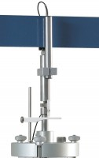 | Axial Strain Transducer Assembly 50mm Travel Fitted with 5 Pin Din Plug.  Code: 27-1617  Attributes: Description = Axial strain transducer assembly 50mm travel, Mounting Bracket = Included as standard.  Standards:

Vertical Displacement Transducer Assembly 15mm Travel with 5 Pin Din Plug Bracket for Shear Box
Code: 27-1689
Attributes: Description = Vertical displacement transducer assembly 15 mm travel, Mounting Bracket = Included as standard.
Standards:

