Dial Gauges
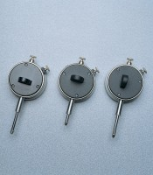 | Dial Gauge  Code: 83-5456  Attributes: Description = Dial gauge 10 mm Travel X 0.01 mm, Back Type = A  Standards:

Dial Gauge
Code: 83-5451
Attributes: Back Type = B, Description = Dial gauge 10 mm Travel X 0.002 mm
Standards:

Dial Gauge
Code: 83-5416
Attributes: Back Type = C, Description = Dial gauge 25 mm Travel X 0.01 mm
Standards:

